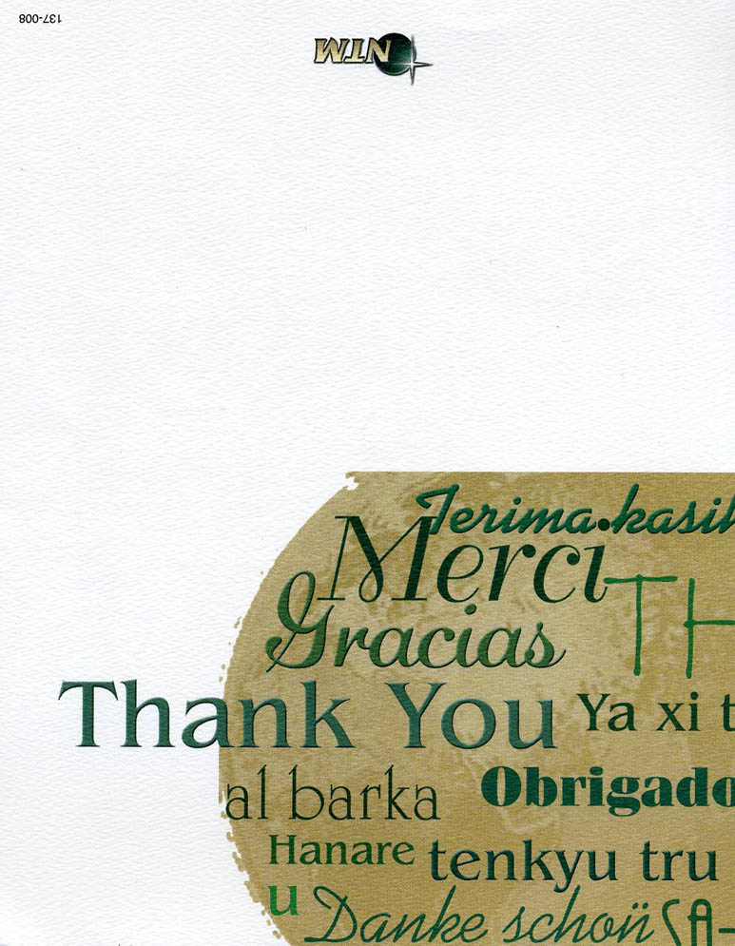
September 2008
Dear Friends and Family,
The Apostle Paul’s words readily come to mind when we think of you: “We give thanks to God always for you all, making mention of you in our prayers.” 1 Thes. 1:2. Thank you also for your faithful prayers for us and the encouragement you bring.
Many people have asked us how we fared during Tropical Storm Fay which recently passed through Sanford. A record 24” of rain fell, causing a lot of flooding here in the Sanford area. We are thankful that we were all safe. We needed repairs under our home, on our air conditioning system, etc. We were without power for a day and a night—memories of 2004! The roads flowed like rivers down our streets, higher than ever before!
God continues to use New Tribes Mission missionaries in taking the Gospel to unreached tribes around the world. The Patpatar people in Papua New Guinea began hearing evangelistic Bible lessons for the very first time on September 8th.
Please pray that the Patpatar people will attend the meetings and listen attentively to the Gospel presentation so that they will understand that Jesus died on the Cross to pay for their sins.
Thank you again for your partnership with us, as together we serve to take the Good News of the Gospel to every kindred, and tongue, and people, and nation. Rev. 5:9.
Have a wonderful day.
John & Linda
Downtown Sanford Florida after Tropical Storm Fay August through September 2008 | 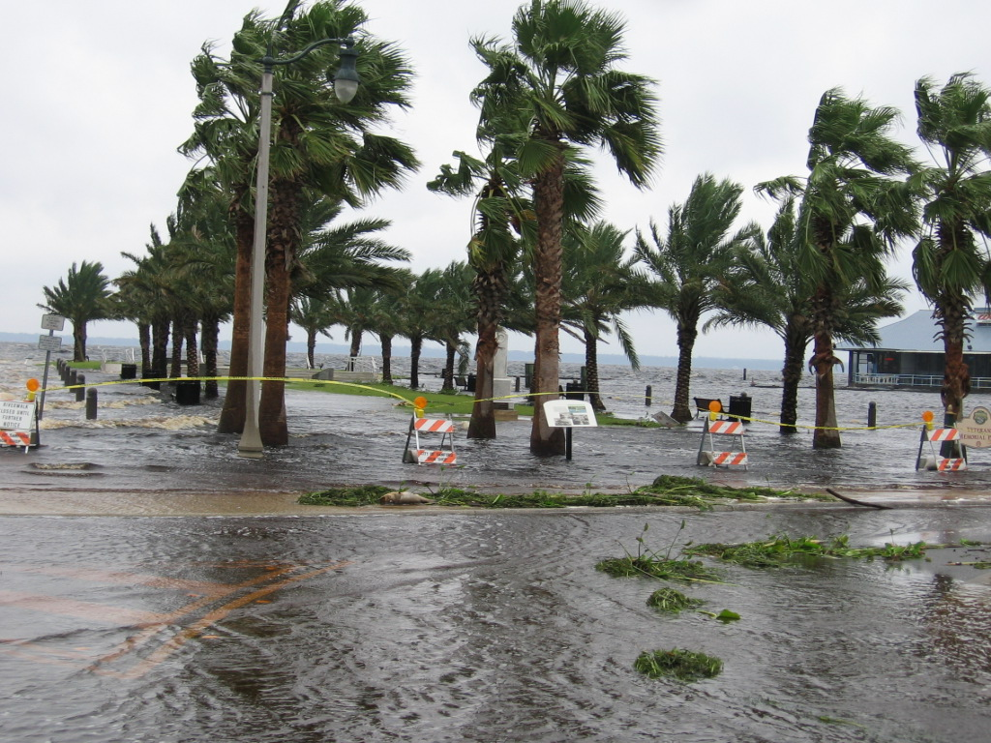 | 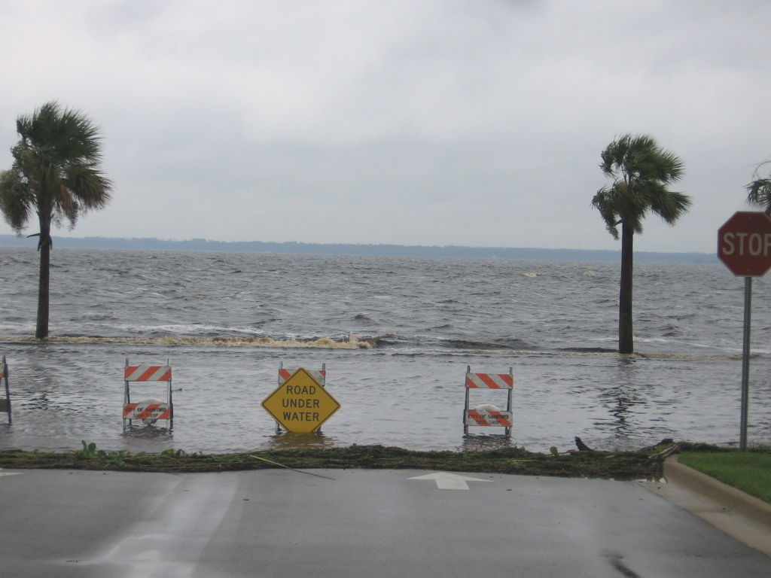

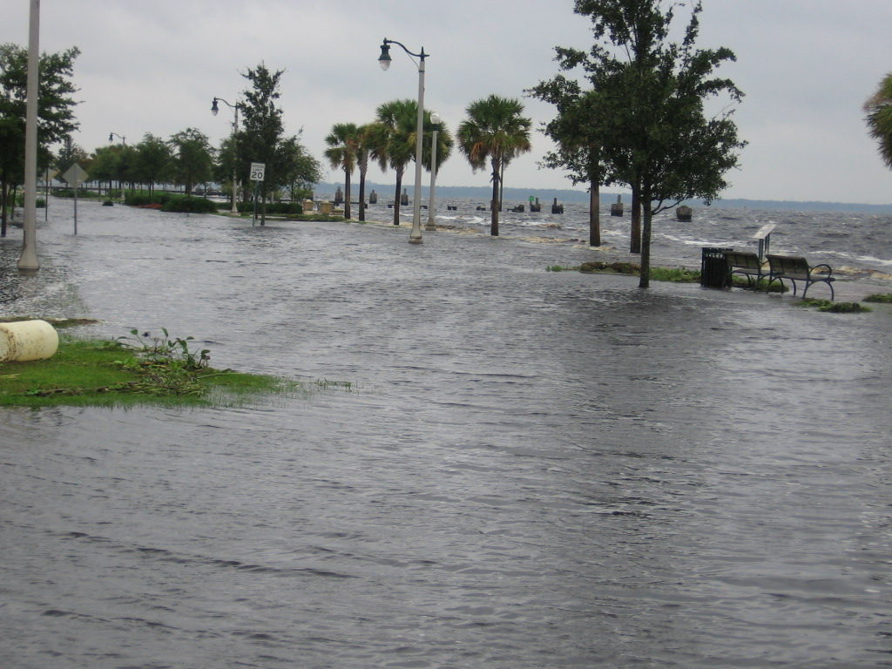 | 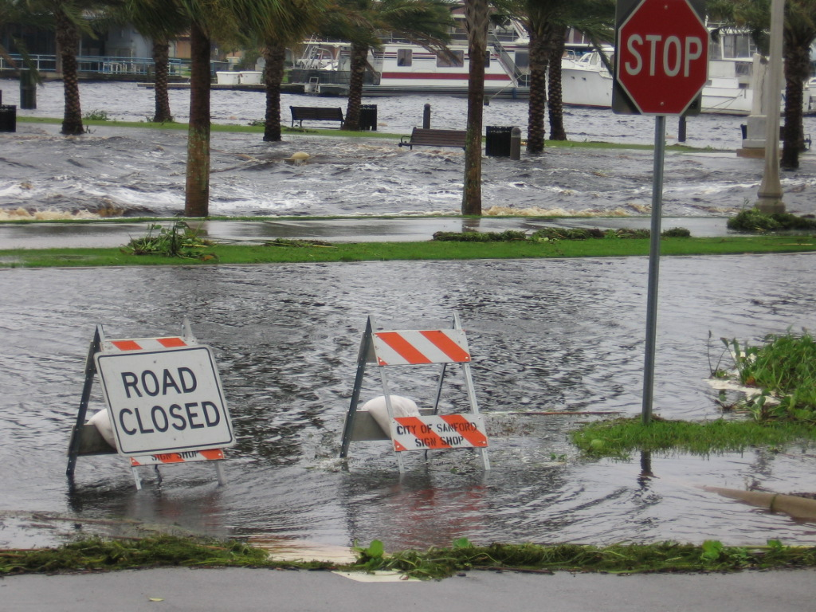 | From  John, Linda, and David McGhee  Grateful  Survivors!

